Sound Processing

Task 1 Report

Fundamental frequency analysis

T2 F1

*Maciej Badura 194401*

*Panos Lennon 201622*

1. Introduction

The aim of our task was to analyse sound signal in time and frequency domain. For this purpose we created an application that reads a \*.wav file, generates a plot for its phase space and detects its fundamental frequency.

2. Phase space analysis

One of our task was to analyse phase space of a provided \*.wav file. The signal is presented in two dimensional space. The x axis represents the original values of the signal and y axis represents values of the original signal shifted by index value k which is an integer. The formula for x and y coordinates of the points in two dimensional phase space can be described as:

(x(i),y(i)) = (f(i),f(i-k))

Where i is the index of the sample in the original set of samples, k is the index of the shift. Algorithm stops when it comes back to the beginning of the phase so when the distance from the starting point and last point is close to zero. Below is an example of the plot that we obtained:

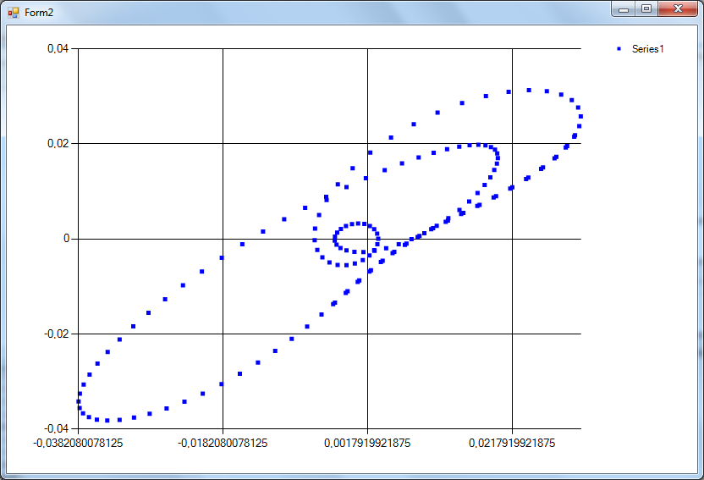

The problem that may appear is when we have a ‘luck’ and start from the point that is a crossing point of phase but is not the end of it the algorithm will stop. To get rid of this issue we started to experiment with different factors. Firstly we started playing with k index, and minimum distance factor which should be close to 0 but not exactly zero. Then we added also more dimensions to the plot to increase distance between crossing points. Below are presented parameters chosen for the plot obtained in the previous image.

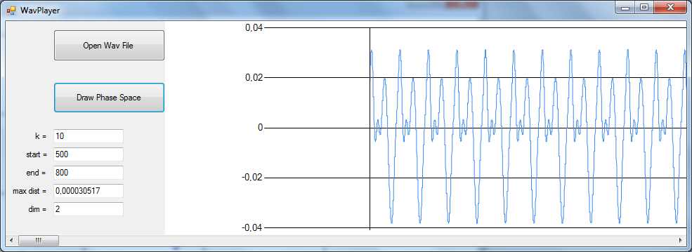

3. Fourier spectrum analysis